August 30, 2026 Name________________________

All Are Welcome

Printed Text

Acts 16:11 - 15 (KJV); Acts 16:40 (KJV)

1. Do you believe Barnabas agreed with Paul that they should go on a
second missionary journey?

Yes or No Acts 15:36 (KJV)
And some days after Paul said unto Barnabas,
Let us go again and visit our brethren
in every city where we have preached
the word of the Lord, and see how they do.

2. Give the name of the person that Barnabas selected to be on the team for
the second missionary journey.

Barnabas selected _________________

Acts 15:39 (KJV)
And the contention was so sharp between them,
that they departed asunder one from the other:
and so Barnabas took Mark, and sailed unto Cyprus;

3. Give the name of the person that Paul selected to be on the team for the
second missionary journey.

Paul selected ____________

Acts 15:40 (KJV)
And Paul chose Silas, and departed,
being recommended by the brethren unto the grace of God.
4. In each of the following Scriptures, circle the places that Paul and Silas
visited during the second missionary journey.

And he went through Syria and Cilicia, confirming the churches.
● Acts 15:41 (KJV)

Then came he to Derbe and Lystra: and, behold, a certain Disciple
was there, named Timotheus, the son of a certain woman, which
was a Jewess, and believed; but his father was a Greek:
● Acts 16:1 (KJV)

Which was well reported of by the brethren that were at Lystra and
Iconium. ● Acts 16:2 (KJV)

Now when they had gone throughout Phrygia and the region of
Galatia, and were forbidden of the Holy Ghost to preach the word
in Asia, ● Acts 16:6 (KJV)

After they were come to Mysia, they assayed to go into Bithynia:
but the Spirit suffered them not. ● Acts 16:7 (KJV)

And they passing by Mysia came down to Troas. ● Acts 16:8 (KJV)

And a vision appeared to Paul in the night; There stood a man of
Macedonia, and prayed him, saying, Come over into Macedonia,
and help us. ● Acts 16:9 (KJV)

And after he had seen the vision, immediately we endeavoured to
go into Macedonia, assuredly gathering that the Lord had called us
for to preach the gospel unto them. ● Acts 16:10 (KJV)

Therefore loosing from Troas, we came with a straight course to
Samothracia, and the next day to Neapolis; ● Acts 16:11 (KJV)

And from thence to Philippi, which is the chief city of that part of
Macedonia, and a colony: and we were in that city abiding certain
days. ● Acts 16:12 (KJV)
5. The riverside outside the city of Philippi was known by the Christian

community as a place of ____________.

Acts 16:13 (KJV)
And on the sabbath we went out of the city by a river side,
where prayer was wont to be made; and we sat down,
and spake unto the women which resorted thither.

6. Do you think Lydia was economically poor?

Yes or No

Acts 16:14 (KJV)
And a certain woman named Lydia, a seller of purple,
of the city of Thyatira, which worshipped God, heard us:
whose heart the Lord opened, that she attended
unto the things which were spoken of Paul.

7. How did Lydia respond to the Gospel message that Paul preached?

______________________________________________________

___________________________________________________________

Acts 16:15 (KJV)
And when she was baptized, and her household,
she besought us, saying, If ye have judged me to be faithful
to the Lord, come into my house, and abide there.
And she constrained us.

8. While Paul was going to prayer, a damsel followed him.
Do you think the damsel was filled with the Holy Spirit?

___________________________________________________________

Acts 16:16 (KJV)
And it came to pass, as we went to prayer,
a certain damsel possessed with a spirit of divination met us,
which brought her masters much gain by soothsaying:

9. The damsel was publicly proclaiming that Paul was preaching the way of
salvation.
Do you think her testimony helped or hurt the Gospel Message?

___________________________________________________

Acts 16:17 (KJV)
The same followed Paul and us, and cried, saying,
These men are the servants of the most high God,
which shew unto us the way of salvation.

10. How did Paul react to the damsel’s continued testimony?

___________________________________________________

________________________________________________________

Acts 16:18 (KJV)
And this did she many days. But Paul, being grieved,
turned and said to the spirit, I command thee
in the name of Jesus Christ to come out of her.
And he came out the same hour.

11. When the damsel was no longer possessed by the demon of divination,
she could no longer earn money for her handlers as a fortuneteller. The
handlers of the damsel began to lose money.

What was the reaction to this great economic loss?

_________________________________________________________

_________________________________________________________

Acts 16:20 (KJV)
And brought them to the magistrates, saying,
These men, being Jews, do exceedingly trouble our city,

Acts 16:23 (KJV)
And when they had laid many stripes upon them,
they cast them into prison, charging the jailor to keep them safely:
12. How did Paul and Silas get out of prison? ►________________________

Acts 16:26 (KJV)
And suddenly there was a great earthquake,
so that the foundations of the prison were shaken:
and immediately all the doors were opened, and every one’s bands were loosed.

13. Where did Paul and Silas go after they left the prison?

a. Paul and Silas quickly left the town.

b. Paul and Silas went to the jailer’s house.

c. Paul and Silas immediately went to Lydia’s house.

Acts 16:34 (KJV)
And when he had brought them into his house,
he set meat before them, and rejoiced,
believing in God with all his house.

14. How did Paul react when the town officials told them that they could go
free?

____________________________________________________

________________________________________________________

Acts 16:38 - 39 (KJV)
³⁸ And the serjeants told these words unto the magistrates: and they feared,
when they heard that they were Romans. ³⁹ And they came and besought them,
and brought them out, and desired them to depart out of the city.

15. What did Paul and Silas do before they left the city of Philippi?

_______________________________________________________

Acts 16:40 (KJV)
And they went out of the prison, and entered into the house of Lydia:
and when they had seen the brethren,
they comforted them, and departed.

PRINTED TEXT

Acts 16:11-15 (KJV)

¹¹ Therefore loosing from Troas, we came with a straight course to Samothracia, and the next day to Neapolis;

¹² And from thence to Philippi, which is the chief city of that part of Macedonia, and a colony: and we were in that city abiding certain days.

¹³ And on the sabbath we went out of the city by a river side, where prayer was wont to be made; and we sat down, and spake unto the women which resorted thither.

¹⁴ And a certain woman named Lydia, a seller of purple, of the city of Thyatira, which worshipped God, heard us: whose heart the Lord opened, that she attended unto the things which were spoken of Paul.

¹⁵ And when she was baptized, and her household, she besought us, saying, If ye have judged me to be faithful to the Lord, come into my house, and abide there. And she constrained us.

Acts 16:40 (KJV)

⁴⁰ And they went out of the prison, and entered into the house of Lydia: and when they had seen the brethren, they comforted them, and departed.

Deacon Henry L. Goines, Th.D., Teacher brothergoines@aol.com
Adult Teacher, Higher Ground Fellowship Hour (225) 938-4230 (Text)
Mount Pilgrim Baptist Church

Reading Assignment

2 Timothy Chapter 4

I have read 2 Timothy chapter 4.

My favorite verse is 2 Timothy 4: ______

Student’s Full Name _________________________

Date _________________

Exegetical Comments on

2 Timothy 4: ______

______________________________________________________

___________________________________________________________

___________________________________________________________

___________________________________________________________

___________________________________________________________

brothergoines@aol.com
(225) 938-4230 (Text)

Deacon Henry L. Goines, Th.D., Teacher
Adult Teacher, Higher Ground Fellowship Hour
Mount Pilgrim
Paul and Barnabas Acts 13:4 through Acts 14:26
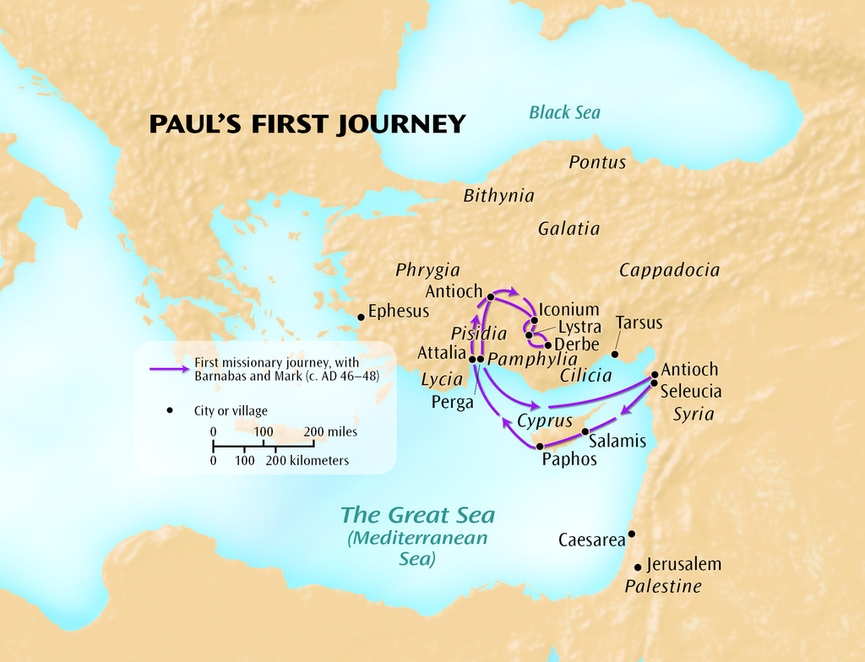

Acts 13:9 (KJV) Then Saul, (who also is called Paul,)
filled with the Holy Ghost, set his eyes on him,

Acts 13:13 (KJV) Now when Paul and his company loosed from Paphos,
they came to Perga in Pamphylia: and John departing
from them returned to Jerusalem.

Acts 18:19-20 (KJV) And there came thither certain Jews from Antioch and Iconium, who persuaded the people, and, having stoned Paul,
drew him out of the city, supposing he had been dead.
²⁰ Howbeit, as the disciples stood round about him, he rose up,
and came into the city: and the next day he departed with Barnabas to Derbe.
Paul and Silas Acts 15:40 through Acts 18:22
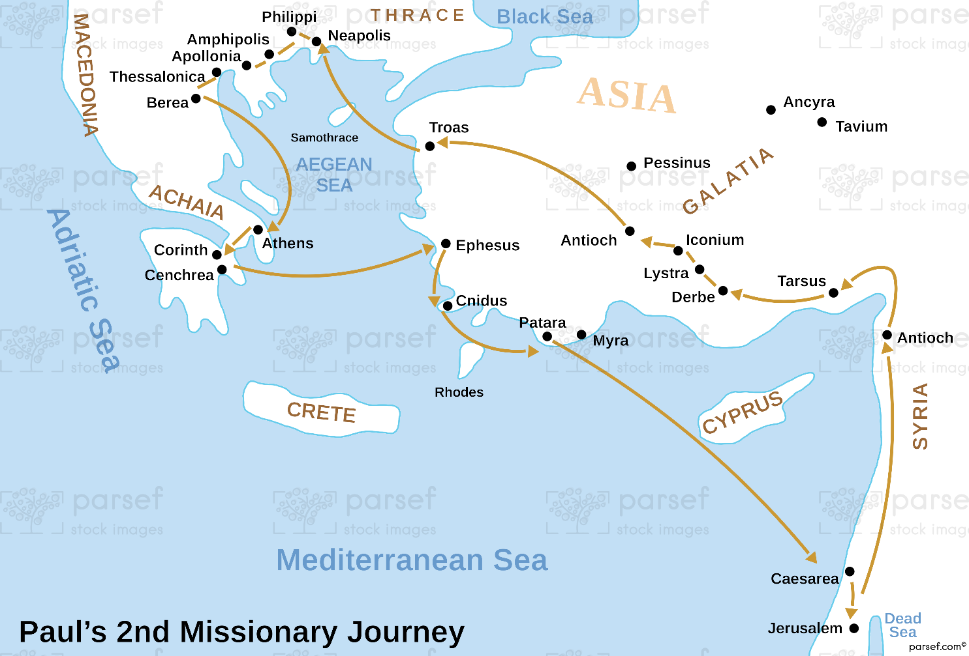

Acts 16:1 (KJV) Then came he to Derbe and Lystra: and, behold,
a certain Disciple was there, named Timotheus, the son of a certain woman,
which was a Jewess, and believed; but his father was a Greek:

Acts 16:23 (KJV) And when they had laid many stripes upon them,
they cast them into prison, charging the jailor to keep them safely:

Acts 18:1-3 (KJV) ¹ After these things Paul departed from Athens,
and came to Corinth; ² And found a certain Jew named Aquila, born in Pontus, lately come from Italy, with his wife Priscilla;
(because that Claudius had commanded all Jews to depart from Rome:)
and came unto them. ³ And because he was of the same craft,
he abode with them, and wrought: for by their occupation they were tentmakers.

Paul and Others Acts 18:23 through Acts 21:17
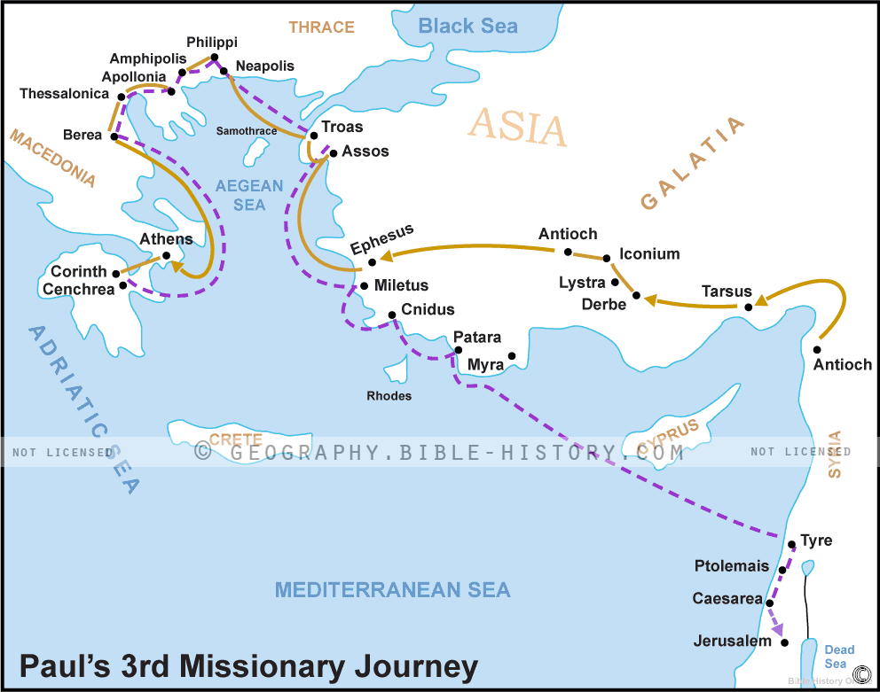

Acts 18:26 (KJV) And he began to speak boldly in the synagogue:
whom when Aquila and Priscilla had heard, they took him unto them,
and expounded unto him the way of God more perfectly.

Acts 20:4 (KJV) And there accompanied him into Asia Sopater of Berea; and of the Thessalonians, Aristarchus and Secundus; and Gaius of Derbe, and Timotheus; and of Asia, Tychicus and Trophimus.

Acts 20:16 (KJV) For Paul had determined to sail by Ephesus, because he would not spend the time in Asia: for he hasted, if it were possible for him, to be at Jerusalem the day of Pentecost.
Paul’s Journey to Rome
Acts 23:23 through Acts 28:16 (KJV)

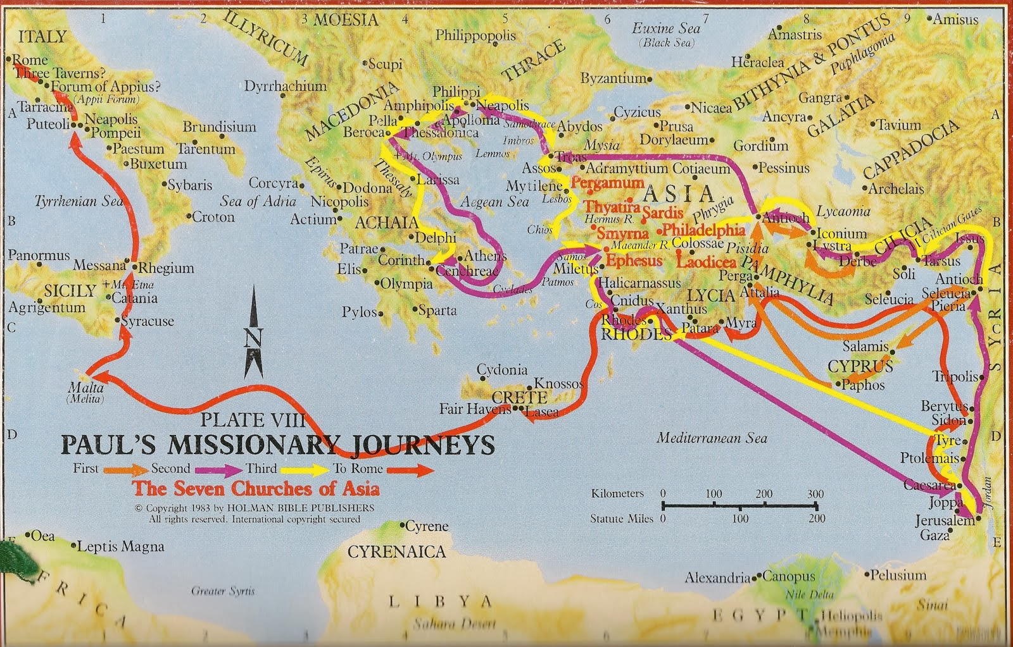

Acts 23:23 (KJV) And he called unto him two centurions, saying,
Make ready two hundred soldiers to go to Caesarea,
and horsemen threescore and ten, and spearmen two hundred,
at the third hour of the night;

